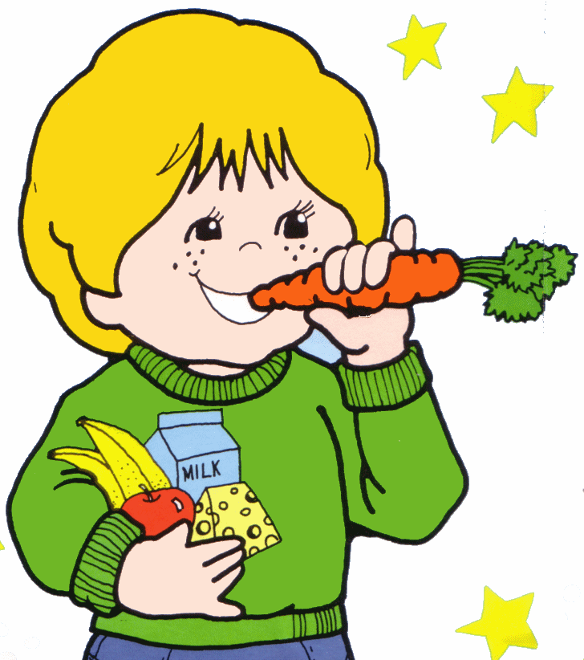

LUNCH & SNACK POLICY

Sharing mealtimes with children gives nursery staff more opportunities to extend children’s learning, particularly with the development of social skills - making choices, negotiating, conversing with friends and adults.

‘Childcare settings are ideal environments to provide opportunities for young children to experience new tastes; develop social skills and enjoy healthy options that will stay with them until adulthood.’
Setting the Table (2015) NHS Health Scotland

Aims:
▪Staff will aim to ensure that lunch and snack times are enjoyable and stress free experiences.

▪Parent’s/carer’s wishes will be respected, regarding their child’s diet.

▪Children will be treated as individuals regarding their likes and dislikes.

▪To develop children’s social skills.

▪To give children the opportunity to experience a variety of foods.

To enable staff to meet these aims they should:
▪Work co-operatively with colleagues in the playroom to ensure consistency with the children.
▪Respond to parent’s/carer’s wishes with regard to the cultural, religious and dietary preferences of their child.
▪Staff will be a role model for good manners.
▪Listen to children’s preferences regarding likes and dislikes, while encouraging them to taste something new.
▪Provide an appropriate portion of food, taking into consideration: the size of the plate, the child’s preferred amount and individual knowledge of the child.
▪Give children time to eat and enjoy conversation at the table.
▪Introduce a variety of food from various cultures and countries during celebrations and festivals.

Good practice - Lunchtime

Before lunch

▪Children should be encouraged to use the toilet, although they would not be prevented from going to the toilet during lunch. Children should wash their hands before lunch.

▪Children are provided with a napkin and encouraged to wear it round their neck or on their lap.
▪Children sit at the table with different friends every day if they wish. At present, due to the COVID -19 pandemic, we are operating ‘Bubbles’ to minimise risk of infection to themselves and to others.

At the table

▪Portions should be small, with extra available i.e. one ladleful of soup unless they request two.
▪Children should be encouraged to use their cutlery. Drinking the last of the soup from the bowl and using a spoon to scoop up peas e.t.c. should not be viewed as inappropriate.
▪If a child has a food allergy or consistently expresses a dislike for something, then an alternative should be requested. Staff should note this information.
▪If a child does not like the pudding, a piece of fruit can be made available.
▪Children should be encouraged to try new foods, however if they continually refuse it then the food should not be put on their plate.
▪Children can have extra when an attempt has been made to eat the food they have asked for or enjoy.
▪They do not have to eat all the extra food that they have requested.
▪Pudding should not be withheld if the main course is not eaten.
▪Playroom staff will stack plates from the tables when all the children are finished.
▪It would be preferable that staff eat with the children, and if eating, it is necessary that they eat the same.

Good Practice - Snacktime

▪Children should wash their hands before snack.
▪Good manners – as above.
▪Water can be substituted for milk.
▪Children can choose from the selection of food provided, state their preferences and the amount they require.
▪Extra snack will be available to those who wish it.
▪A slow eater should be given the time to finish their snack.

Care Standard: 3 Health and wellbeing
Care Standard: 6 Support and development
Care Standard: 8 Equality and Fairness

▪Policy reviewed in January 2021 by Janice and Morag

